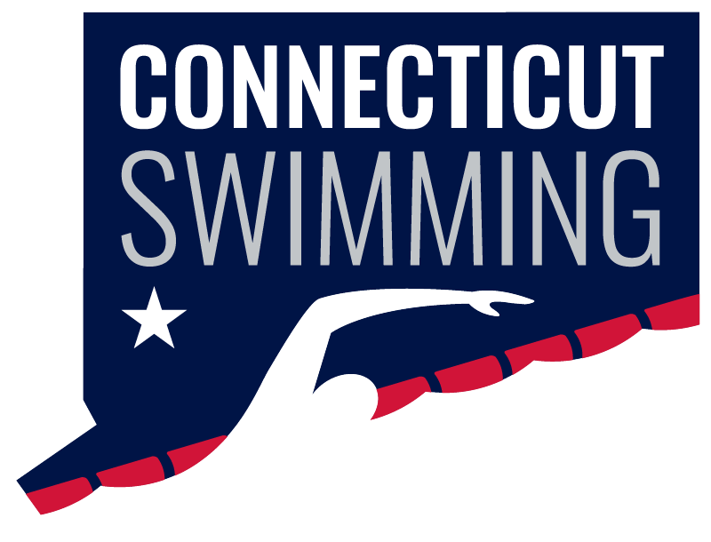
CONNECTICUT SWIMMING
House of Delegates
September, 14, 2025
September 14 - 9:00p
Trumbull Marriott Shelton,
180 Hawley Lane, Trumbull, CT

Vision Statement: Connecticut Swimming…better life through swimming.
Mission Statement: Connecticut Swimming promotes the pursuit of excellence in swimming and in life through competition and education.

Call to Order
Roll Call
Approval of Agenda
Adoption of Minutes – May HOD
Announcements

Final Roll Call for Missing delegates

Reports of Officers, Committee Chairs, and Coordinators
- General Chair Report – Jeff Sargent
- Administrative Vice-Chair – Greg Pinchbeck
- Finance Vice-Chair – Vacant
- Program Development Vice-Chair – Jason Paige
- Program Operations Vice-Chair – Jim Robison
- Athlete Representatives – Caroline Ward, Caroline Gies
  - HOD Athletes: Olivia Edwards, Ilse Fedoronko, Mackenzie Grey, Julia Scalmani, Niya Villanueva
- Treasurer – Jesse York
- Safe Sport Coordinator – Jeremy Virgil
- Diversity, Equity & Inclusion – Dennis Flores, Emmanuel Lanzo
- Senior Committee Chair – Adriana Schack
- Age Group Committee Chair – Mary Kate Haverly, Karim Mabrouk
- Coach Representatives –Steven Cusano, Robert Adams-Michaud, Mario Francisco
- Coach-at-Large – Kristen Finnegan
- Officials Chair – Dylan Lee/Margy Sargent
- Open Water Coordinator – Vacant
- Adapted Swimming - Vacant
- Operational Risk Coordinator – Robert Cristiano
- Registration/Membership Coordinator – Kathleen/Davide Mendonca
- Zone Team Coordinator – Seana Bedard

Old Business

New Business

Discussion/Public Comment
- USA Swimming Annual Summitt September 24-27
- Annual Banquet November 2nd

Adjournment

