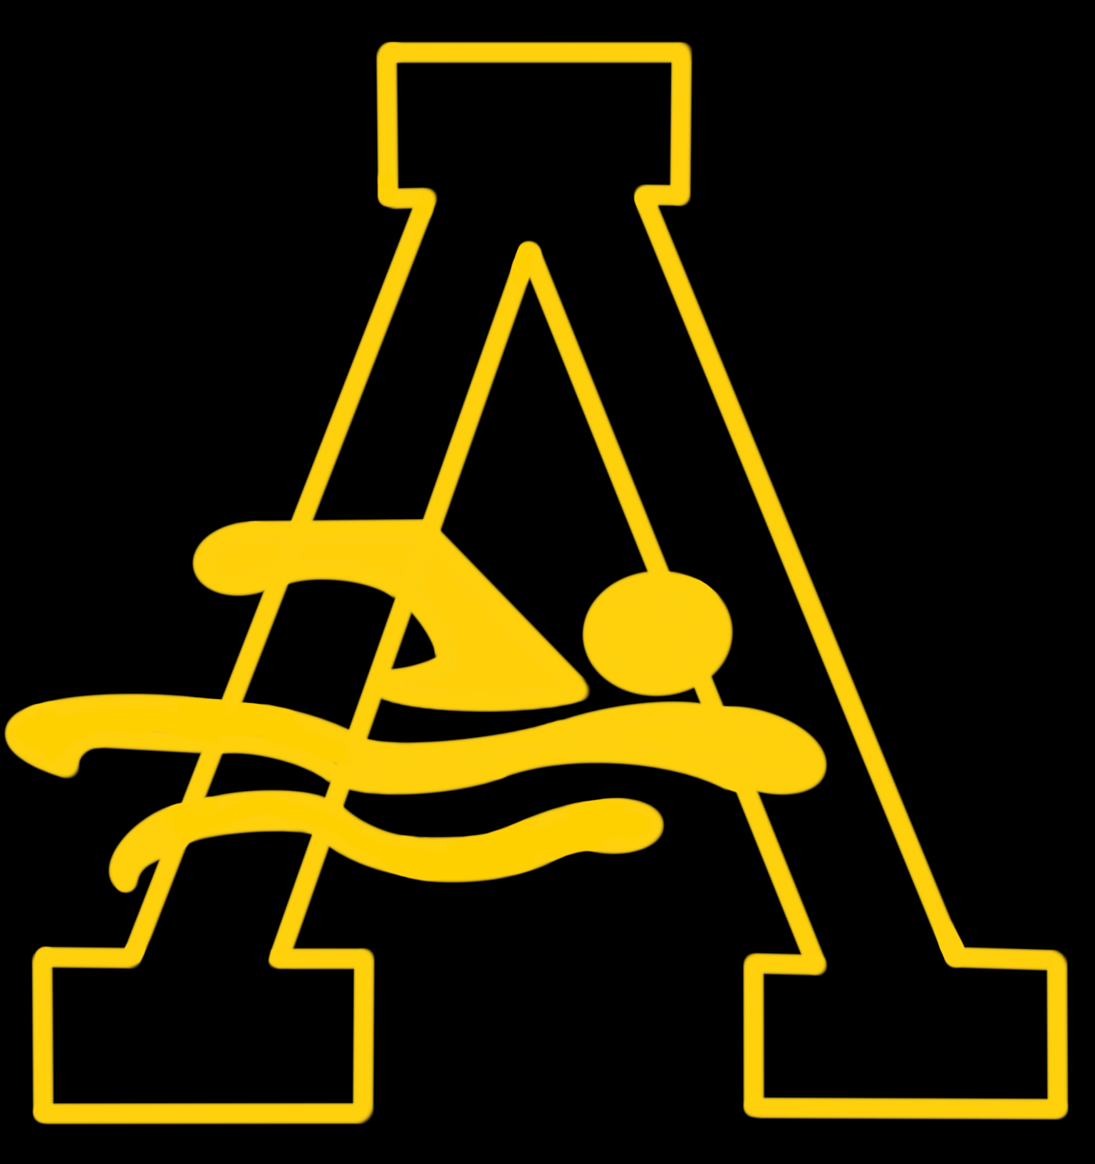

ARAC Developmental Coach (Part-Time)
The Amity Regional Aquatic Club (ARAC), a USA Swimming club in Orange, CT, is seeking an inspiring, energetic part time developmental coach to assist with all practice groups.
Job description:
Seeking a goal oriented/ technique-based coach who can teach the fundamentals of competitive swimming. The start date would be September 2026.

Primary Responsibilities
- Conduct age-appropriate practices focused on technique, skill progression, and engagement
- Teach and reinforce all four competitive strokes, starts, turns, and finishes
- Ensure a safe, positive, and inclusive training environment
- Communicate effectively with swimmers, parents, and coaching staff
- Attend weekend swim meets, as needed; assist with warm-ups and race-day coaching
- Support swimming development aligned with long-term athlete development principles
- Adhere to all USA Swimming and Safe Sport policies

Qualifications
- Previous coaching experience with age-group swimmers (desired)
- Competitive swimming experience at the club, high school, or collegiate level (preferred)
- Strong knowledge of stroke mechanics and swim fundamentals
- Excellent communication and interpersonal skills
- Energetic, organized, and a positive role model
- Passion for youth development

Certifications & Requirements
- Current USA Swimming Coach Membership (or ability to obtain)
- Current CPR, First Aid, and Safety Training for Swim Coaches certifications (or ability to obtain)
- Completion of all required background checks and Safe Sport training

Compensation
Competitive hourly pay based on experience and qualifications. Membership fees and travel will be paid for or reimbursed by the Club.

How to Apply
Interested candidates should submit a resume and references to:
Kelly Bodie (ARAC Board President) kellyabodie@yahoo.com

