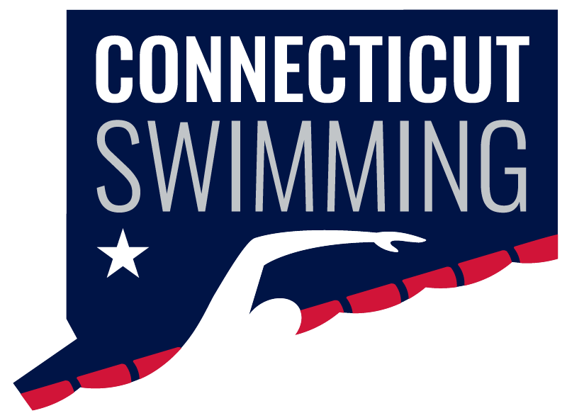
CT Swim Athlete Committee
February 6 @ 8 PM
Meeting ID: 936 0270 9399
Passcode: 806298

Minutes
Attendance: Ava Ward, Caroline Gies, Caroline Ward, Greg Pinchbeck, Greg Pinchbeck, Ilse Fedoronko, Julia Scalmani, Mackenzie Grey, Maya Kreuzer, Olivia Edwards, Niya Villanueva
Absent: Luke Scheinfeldt & Niall Easton
Seniors:
- Decided to not do themes - won't get enough people to participate, so it's not worth it
- We are sorting out a DJ and announcer for finals
- DJ to play music @ finals during warmup, breaks, and walkout songs
- Can anyone attend to get social media coverage @ finals? LMK
Age Groups:
- Themes - will post polls for people to vote on their favorite themes, then we will decide that way
- Possible ideas: Hawaii, Neon, Superheroes, USA, Twin Day, Disco
- Text me with any other ideas you come up with for themes!
- Clip station was a hit - maybe do it again?
- Can anyone attend to get social media coverage @ finals? LMK
March Madness Bellyflop Contest:
- Prize - gift basket/gift card
- Get people to participate!
- To be held after Age Groups, later in March
- Everyone must get someone they know to submit a video (if not, you will have to submit a video)
Jr Athlete Rep Elections/Info Zoom:
- Do you know anyone that might be a good fit for this role?
- We will do a similar thing for our March meeting where we will invite possible candidates to sit on our calls/observe
- Date for Info Zoom to come!
Finding new AC members & new At-Large reps:
- Possibly could be a separate application - some people might want to be on the AC but not take on the role of jr/sr rep
- Look for distribution of males/females, small/large teams, location, etc, but ultimately we need to take the people who are interested
- AC members don't have to be sophomores - just in high school - can serve 1 year if they want
- Caroline Gies will reach out to all of you to see if you are planning on serving another year on the AC so we can figure out what our numbers are looking like
Open Water Championship:
- Do a better job of publicizing and more in advance
- Look into blocking off the day from any other meets so people don't have to pick between participating in this or another meet
SAA:
- Possible idea: CT Swim SAA Month in June - get people to sign up under our team, compete with NJ to see who can raise the most money, clubs would do their own pool swims during the month to raise money (just dedicate a practice to it, doesn't need to be anything major)
- Possible idea: simply publicize volunteering (swim, set up, clean up, etc) on social media to try and help w/participation
EZ Athlete Summit:
- Here is the link to the presentation with all of the details, take a look!
- Let me know if you are interested in attending

