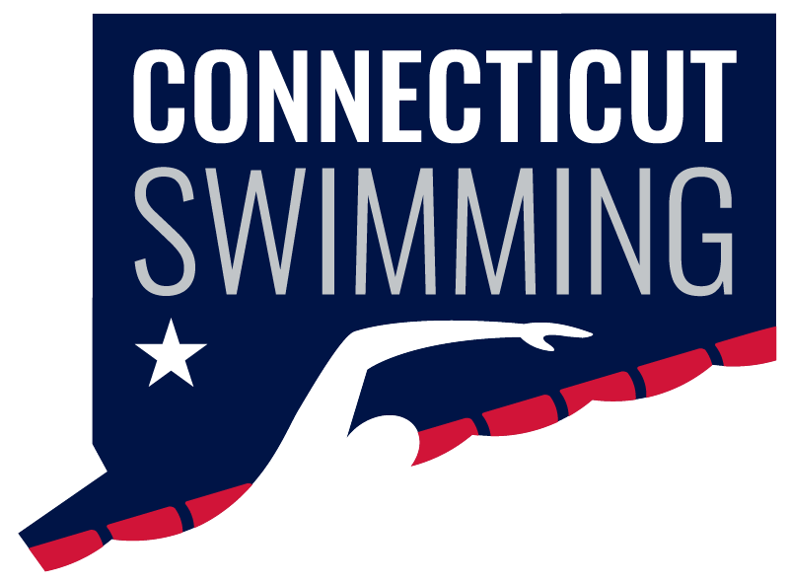
CT Swim Athlete Committee
Minutes
March 12 @ 8 PM
Meeting ID: 936 0270 9399
Passcode: 806298

Minutes
Attendance: Caroline Gies, Caroline Ward, Greg Pinchbeck, Greg Pinchbeck, Ilse Fedoronko, Mackenzie Grey, Maya Kreuzer, Olivia Edwards, Niya Villanueva
Absent: Ava Ward, Luke Scheinfeldt, Julia Scalmani, Niall Easton
Feedback about Seniors:
- The DJ was great, everyone loved it, the energy was so much higher, and people were dancing!
  - Sometimes it was hard to hear the announcer and DJ - DJ playing music over announcer during short announcements - something to try and fix for the future
- The social media coverage/little videos we did were a hit!
  - Better to do short videos with a bunch of people rather than a longer video with one person
  - Lots of people reposted them
  - Try to get people from the same team to answer different questions
  - Try to get as many teams represented as possible!
- A lot of swimming for the HS boys with states
- Bluefish - people were confused why they were there and were murmuring about it (combination of them not necessarily being from CT and them being fast swimmers/qualifying for finals)
- Too many 10 minute breaks!! Not needed after every event at finals because we already have cool down space open
- The timeline for warm up/meet in general needs to be stuck with in the future (unless weather/other unexpected issues), it is not fair to swimmers/athletes/parents/officials to change that by an hour and a half the day before
- The later warmup time was liked for prelims (as long as it was advertised in advance/planned to be that way)
- For LC we need to plan some sort of senior recognition!
March Madness Bellyflop Contest: we have a lot of submissions and the bracket will start on Monday! Excited to get this rolling, and thank you all for submitting videos!
Jr Rep Elections: we are midway through the application window, then the selection window will be from March 21-April 3, and the voting period will be April 3-11
AC Recruitment/Application for new members:
- We have a lot of interest in joining!
- We only have 4/5 spots open (really 2/3 w/At Large Reps)
- Notes on discussion:
  - Less intensive application/use the same Athlete Rep application for people who applied for that so they don't have to redo
  - Offer to people who wanted to be Jr rep
  - Get a small video/description written by the head of other committees so people can join those as well
  - Can have non-sophomores
  - No freshman (?)
  - Term limit (?)
  - Keep a list of interested people for future years
- This is something to continue to work on and get more of a firm/in the bylaws outline for how this works in the future!
DEI/All-Star Camp:
- April 18-19 @ Hamden Hall - we need people (or multiple) to attend and get social media coverage
- Email/text me if you can (even just 1 of the days)
EZ Summit Attendees: Niya & Blake
Medals: all squared away and ordered for LC!! They look great.

Next BOD meeting: March 17

