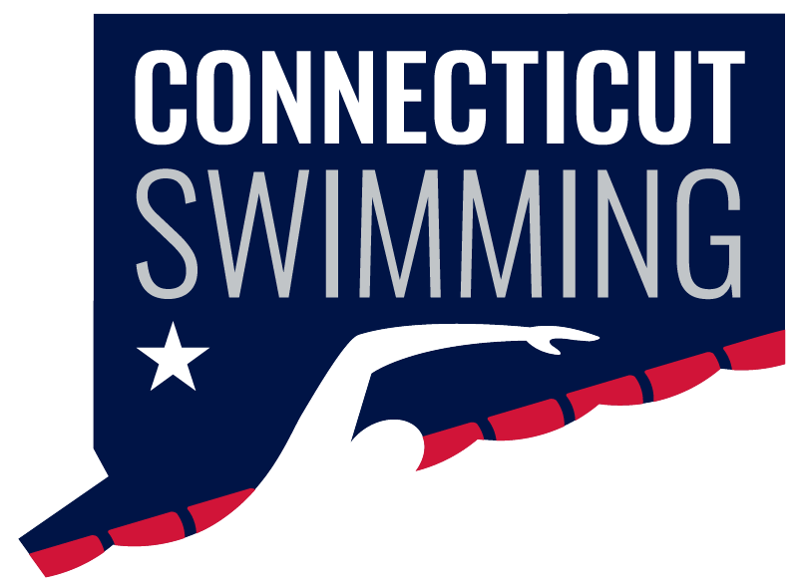
CT Swim Athlete Committee
May 20 at 8:00p
Meeting ID: 936 0270 9399
Passcode: 806298

Minutes
Attendance: Brianna Laforest, Caroline Gies, Caroline Ward, Greg Pinchbeck, Greg Pinchbeck, Ilse Fedoronko, Luke Scheinfeldt, Maya Kreuzer, Olivia Edwards, Niya Villanueva, Maryn Brooks (non-committee member), Matthew Ackerman (non-committee member), Kylee Grey (non-committee member)
Absent: Ava Ward, Julia Scalmani, Mackenzie Grey

New Members/Transition:
- This meeting is my last time running our AC, Caroline Gies will take over in June, and has already taken over for BOD/HOD meetings going forward
- Welcome to Bri, we are very excited to have you!
- We gave a list to the General Chair for new BOD At Large and AC members - we are waiting for his approval/discretion, and hopefully can invite new members for the June meeting
USA Swimming LSC Awards:
- We should apply for a few of these in the Fall, so we brainstormed how our projects fit into the awards
- See the attached doc!
Open Water Championship:
- WYW team will be there - can get social media coverage
- Do a good job with promoting in the coming weeks to make it a well attended and positive event
Celebrating Graduating Seniors:
- @ LC Seniors, maybe at Saturday at the beginning of finals
- Some sort of parade where the seniors from each team are announced - take pictures in front of the backdrop and wear their college shirt
- On social media - do a similar thing to last year with the dropbox, maybe do baby pictures too this year?
Brainstorm for Social Media:
- Edit together the coaches footage from Age Groups
- Go to local meets and make interview videos (like the AG/Seniors ones)
- Instagram takeovers - just have people send the clips to the Athlete Reps to post (don't want to give login info for the account away)
- Do a summer series of Day In My Life - maybe weekly/bi weekly from teams across the state
- Niya & Blake to get content @ Summit
Swimposium:
- We won't be able to host another in person swimposium this year, but maybe could do a zoom series throughout the year?
- 30ish mins each, short quick informational sessions to help athletes - do multiple shorter zooms rather than a few longer ones
- Possible topics: nutrition, mental health, recruiting background (overview, importance, etiquette, different divisions, etc), national team member, visualization, meditation, recovery, safe sport (info session), junior official (info session), drylands (importance, education)
Lastly, a huge thank you to our seniors who are rolling off! You have done such an incredible job setting the foundation for the AC and should be proud of all of the work that you have put in! We will be cheering you on in your next chapters!

