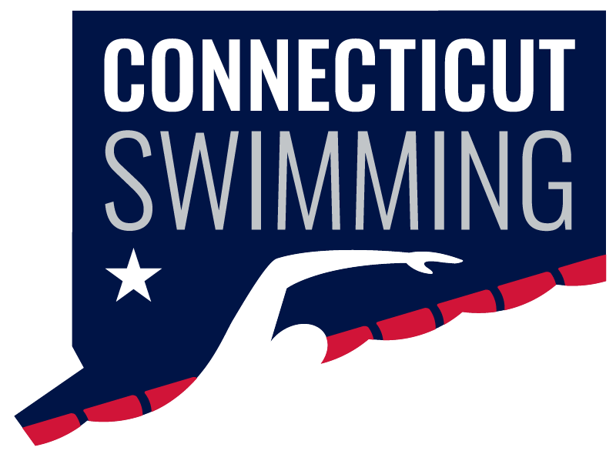
CT Swim Athlete Committee
June 4th at 8:00p
Meeting ID: 936 0270 9399
Passcode: 806298

Minutes
Attendance: Brianna Laforest, Caroline Gies, Caroline Ward, Greg Pinchbeck, Greg Pinchbeck, Ilse Fedoronko, Maya Kreuzer, Niya Villanueva, Olivia Edwards, Matthew Ackerman (non-committee member), and Maryn Brooks (non-committee member)
Absent: Luke Scheinfeldt
Open Water Championship
- Brainstormed content ideas to increase engagement, including race coverage, athlete interviews, course information, and educational posts about open water swimming.
- Discussed opportunities to highlight athletes from across Connecticut and promote the event through social media.
Emory Leadership Summit
- Planned content collection from the summit, including photos, videos, and day-in-the-life features.
- Discussed sharing key takeaways with Connecticut Swimming and identifying ideas that could be implemented within our LSC.
Swim Across America
- Discussed opportunities to support and promote Swim Across America.
- Explored ways Athlete Committee members can get involved through community service and event coverage.
Summer Content & Fundraising
- Generated ideas for summer content series, including athlete interviews, trivia, and day-in-the-life features.
- Brainstormed potential fundraising initiatives and opportunities to collaborate with other organizations and LSCs.
Increasing Officials
- Developed several ideas to recruit and recognize officials, including family spotlights, educational content, and promotional videos.
- Discussed ways to better communicate officiating opportunities to swimmer families.
Long Course Seniors
- Continued planning for senior recognition efforts, including social media features and meet-day recognition opportunities.
- Discussed potential donation drives (TBD) and ways to increase coverage of senior athletes throughout the season.
Long Course Age Groups
- Brainstormed content ideas focused on athlete experiences, team spirit, coach interviews, and positive recognition.
Athlete Committee Growth
- Discussed strategies for recruiting additional athletes and maintaining strong Athlete Committee involvement moving forward.
I also included our more in-depth notes from the meeting below.

