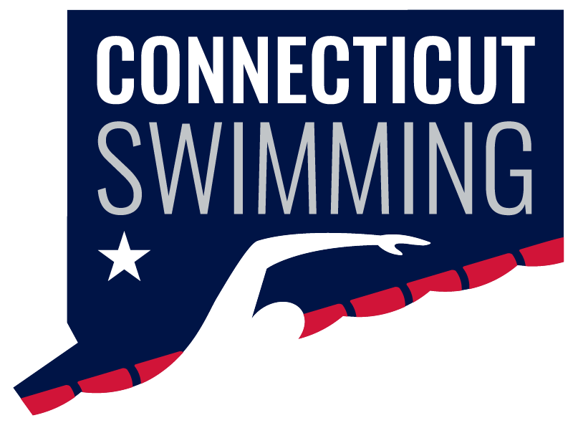
CT Swim Athlete Committee
July 3rd at 8:00p
Meeting ID: 936 0270 9399
Passcode: 806298

Minutes
Absent: Greg Pinchbeck (Jr.), Luke Scheinfeldt, Olivia Edwards, Matthew Ackerman
Present: Caroline Gies, Bri Laforest, Ilse Fedoronko, Maya Kreuzer, Niya Villanueva, Kylee Grey, Maryn Brooks, Shayla Knolker
Non-committee member: Blake Carlson

- New Athlete Committee Members: Welcome to our new members! Please send me your photo by July 6.
- USA Swimming Leadership Summit: Blake and Niya shared highlights from the summit, including leadership, Safe Sport, junior officials/coaches, and the idea of creating an Athlete Representative Survival Guide.
- Officials Campaign: We brainstormed ideas for encouraging more officials, including interviewing an officiating family and promoting the positive impact officials have on our sport.
- Open Water Feedback:
  - Advertise the meet earlier.
  - Create a course preview video.
  - Use a speaker for race briefings.
  - Remove the $10 breakfast voucher.
  - Use the CT Swim backdrop for awards and photos.
- Senior Recognition: We are continuing to work with the Senior Committee on a senior recognition slideshow.
- Age Group Championships: We discussed interviews, social media coverage, and other content ideas for the meet. I'll also check on having a DJ.
- Banquet: The CT Swimming Banquet will be on November 1, with Zach Harting serving as our emcee. We'll be promoting him on social media before the event, and Brianna and Olivia will interview him while in Denver.

