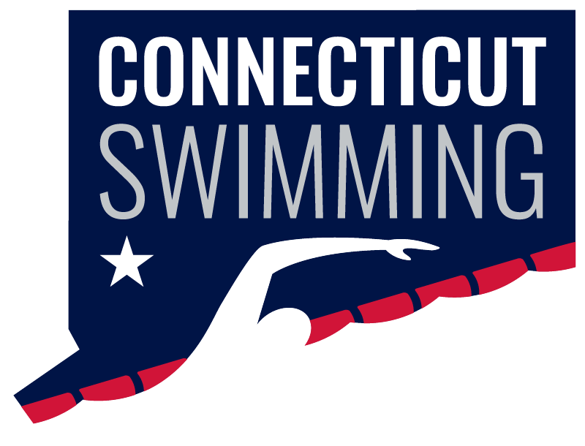
Board of Directors
April 23 - 8:00p
Via Zoom
Meeting ID: 964 6042 9519
Passcode: 026633

https://zoom.us/j/96460429519?pwd=elhFTUNHRnYzRzdsMTJBaTlVOUt2dz09
Vision Statement: Connecticut Swimming…better life through swimming.
Mission Statement: Connecticut Swimming provides opportunities for swimmers to enrich their lives.
AGENDA
Call to Order/Roll Call
Announcements
Approval of Agenda/Additions to Agenda
Adoption of Minutes March – tabled for April

General Chair Announcements and Updates

Old Business
- Governance
  - Board Self Assessment Survey – Greg
  - Open Board Roles and Elections - Dave Heller
- FAST/SWIMS 3.0 update – Henk, Davide
- CSI Publicity Committee Update – Dave
- 2024-25 CSI Budget Vote - Joan

New Business
- CSI Financials – Sue
- Wesleyan meeting – Jeff, Rick, Henk
- CT Swim Logo approval - Henk

Reports of Officers, Committee Chairs, and Coordinators
- General Chair Report – Rick Lewis
- Administrative Vice-Chair – Jeff Sargent
- Treasurer – Susan Lecza
- Finance Vice-Chair – Joan Lynch
- Age Group Committee Chair – Ronnie Vaughan
- Senior Committee Chair – Sean Farrell/Adriana Schack
- Technical Planning Committee Chair – Jason Paige
- Program Development Vice-Chair – Jen Lyman
- Program Operations Vice-Chair – Yolanda Jahan
- Officials Chair – Dylan Lee/Margy Sargent
- Operational Risk Coordinator – Brandon Foster
- Coach Representatives –Rob Riccobon, Sarah Basile
- Athlete Representatives – Madison Winslow/Samantha Haley
- Safe Sport Coordinator – Jeremy Virgil
- Coach-at-Large – Nick Cavataro
- Registration/Membership Coordinator – Kathleen/Davide Mendonca
- Zone Team Coordinator – Dana Parsons
- Diversity, Equity & Inclusion – Dennis Flores

Next meeting May 21.

