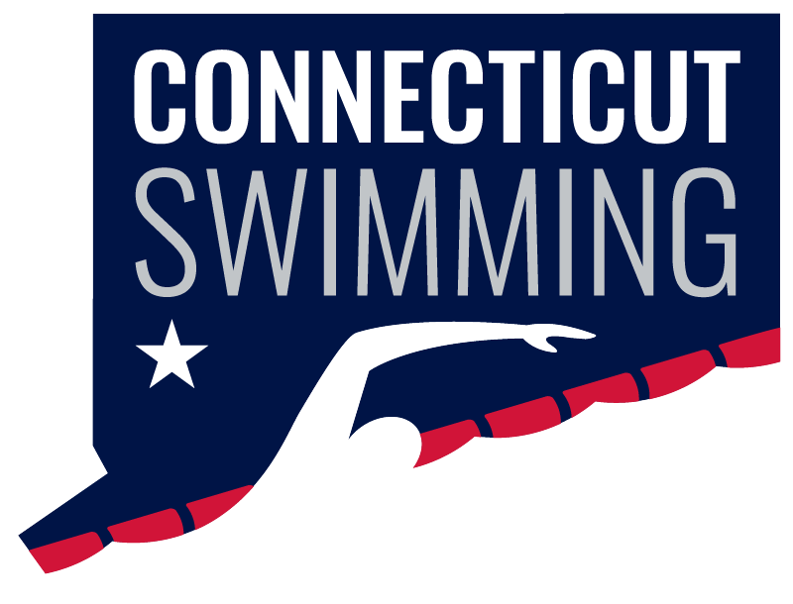
Board of Directors
July 2 - 8:00p
Via Zoom
Meeting ID: 964 6042 9519
Passcode: 026633

https://zoom.us/j/96460429519?pwd=elhFTUNHRnYzRzdsMTJBaTlVOUt2dz09
Vision Statement: Connecticut Swimming…better life through swimming.
Mission Statement: Connecticut Swimming provides opportunities for swimmers to enrich their lives.
AGENDA
Call to Order/Roll Call
Announcements
Approval of Agenda/Additions to Agenda
Adoption of Minutes May - tabled

General Chair Announcements and Updates

Old Business
- Governance – Greg
- FAST/SWIMS 3.0 update – Henk, Davide

New Business
- CSI Financials – Sue
- Seniors/Age Groups Final Prep – Sean/Ronnie
- 2025 SC Wesleyan Dates – March 6-9, 13-16
- Championship Meet Scheduling - Margy
- SC Meet Bid dates – Henk
- Regional bid committee - Henk

Reports of Officers, Committee Chairs, and Coordinators
- General Chair Report – Rick Lewis
- Administrative Vice-Chair – Jeff Sargent
- Treasurer – Susan Lecza
- Finance Vice-Chair – Joan Lynch
- Age Group Committee Chair – Ronnie Vaughan
- Senior Committee Chair – Sean Farrell/Adriana Schack
- Technical Planning Committee Chair – Jason Paige
- Program Development Vice-Chair – Jen Lyman
- Program Operations Vice-Chair – Vacant
- Officials Chair – Dylan Lee/Margy Sargent
- Operational Risk Coordinator – Brandon Foster
- Coach Representatives –Sarah Basile, Steven Cusano and Robert Adams-Michaud
- Athlete Representatives – Samantha Haley, Caroline Ward
- Safe Sport Coordinator – Jeremy Virgil
- Coach-at-Large – Nick Cavataro
- Registration/Membership Coordinator – Kathleen/Davide Mendonca
- Zone Team Coordinator – Seana Bedard
- Diversity, Equity & Inclusion – Dennis Flores

Next meeting

