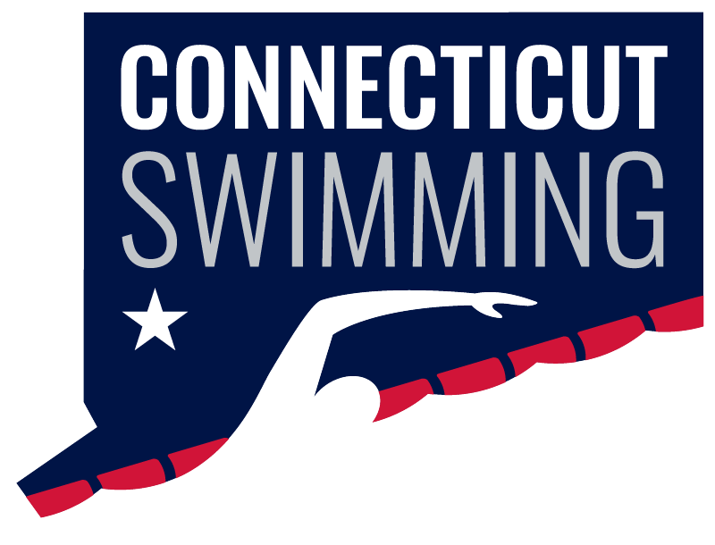
Board of Directors
September 17 - 8:00p
Via Zoom
Meeting ID: 964 6042 9519
Passcode: 026633

https://zoom.us/j/96460429519?pwd=elhFTUNHRnYzRzdsMTJBaTlVOUt2dz09
Vision Statement: Connecticut Swimming…better life through swimming.
Mission Statement: Connecticut Swimming provides opportunities for swimmers to enrich their lives.
AGENDA
Call to Order/Roll Call
Approval of Agenda
Adoption of Minutes - July

General Chair Announcements and Updates
Admin Vice Chair Announcements and Updates
CSI Financials

Old Business
- None

New Business7
- Junior Official position – Margy and Dylan
- Fall HOD date – Jeff
- New Top 16 Open Water events for 2025 – Greg
- Program Operations - Jeff

Reports of Officers, Committee Chairs, and Coordinators
- General Chair Report – Jeff Sargent
- Administrative Vice-Chair – Greg Pinchbeck
- Finance Vice-Chair – James Doak
- Program Development Vice-Chair – Jason Paige
- Program Operations Vice-Chair – Jim Robison
- Athlete Representatives – Samantha Haley, Caroline Ward
- Treasurer – Susan Lecza
- Safe Sport Coordinator – Jeremy Virgil
- Diversity, Equity & Inclusion – Dennis Flores, Emmanuel Lazo
- Senior Committee Chair – Adriana Schack
- Age Group Committee Chair – Ronnie Vaughan
- Coach Representatives –Sarah Basile, Steven Cusano and Robert Adams-Michaud
- Coach-at-Large – Kristen Finnegan
- Officials Chair – Dylan Lee/Margy Sargent
- Open Water Coordinator – Vacant
- Adapted Swimming - Vacant
- Operational Risk Coordinator – Brandon Foster
- Registration/Membership Coordinator – Kathleen/Davide Mendonca
- Zone Team Coordinator – Seana Bedard

Next meeting

